|  |  |  |  |  |  |
| --- | --- | --- | --- | --- | --- |
| **Declaration** |  | | | | |
| Questions in this exercise are intentionally complex and could be convoluted or confusing. This is by design and to simulate real life situations where customers seldom give crystal clear requirements and ask unambiguous questions. | | | | | |
|
|
| I have read the above statement and agree to these conditions | | | | | |
| I AGREE | Jyoti Mohanty | | | | |
| <Enter your name above this line to indicate that you are in agreement> | | | | |
|  |  |  |  |  |  |
|  |  |  |  |  |  |
| **Instructions** |  |  |  |  |  |
| Every screenshot requested in this workbook is compulsory and carries 1 marks | | | | | |
| Your AWS account ID must be clearly visible in every screenshot using the AWS console; missing id or using someone else's id is not permitted. Such cases will be considered as plagiarism and severe penalty will be imposed. | | | | | |
| All screenshots must be in the order mentioned under "Expected Screenshots" for every step | | | | | |
| DO NOT WAIT UNTIL THE LAST MINUTE. The program office will not extend the project submission deadline under any circumstances. | | | | | |
| The file should be renamed in the format BATCH_FIRSTNAME_LASTNAME_PROJECT1.  For example: PGPCCMAY18_VIJAY_DWIVEDI_PROJECT1.pdf | | | | | |
|  |  |  |  |  |  |
|  |  |  |  |  |  |
| **Resource Clean Up** | |  |  |  |  |
| Cloud is always pay per use model and all resources/services that we consume are chargeable. Cleaning up when you’ve completed your lab or project is always necessary. This is true whether you’re doing a lab or implementing a project at your workplace. | | | | | |
| After completing the lab, make sure to delete each resource created in reverse chronological order. | | | | | |

|  |  |
| --- | --- |
| **Implementation** | |
| 1 | Create an Azure VM using the given specifications in the instructions |
| 2 | Setup IIS on the virtual machine |
| 3 | Use Traffic Manager to direct traffic to the VM |
| 4 | (Optional) Modify the home page of IIS to display a custom message |

**Step 1 : Virtual Machine Creation**

|  |  |
| --- | --- |
| Step number | a |
| Step name | Creation of Virtual Machine |
| Instructions | 1) Login to the Azure portal of your Azure account  2) Use the search bar at the top of the screen to navigate to Resource groups  3) Select “New” and create a resource group in any region of your choice  4) Navigate to Virtual Machines using the search bar and select “Add”  5) Create a virtual machine in the created Resource Group using the specifications given below: **Instance:Windows 2019 Data Center**  **VM Size: DS1- v2**  **Inbound ports : 3389, 80 and 443. (Same ports to be allowed for network interface)**  **Authentication type: Password**  **Load Balancing : No**  **Rest of the options can be left as default** |
| Expected screenshots | 1) Created Resource Group 2) Created Virtual Machine . |

**<Insert screenshot for a(1) here>**

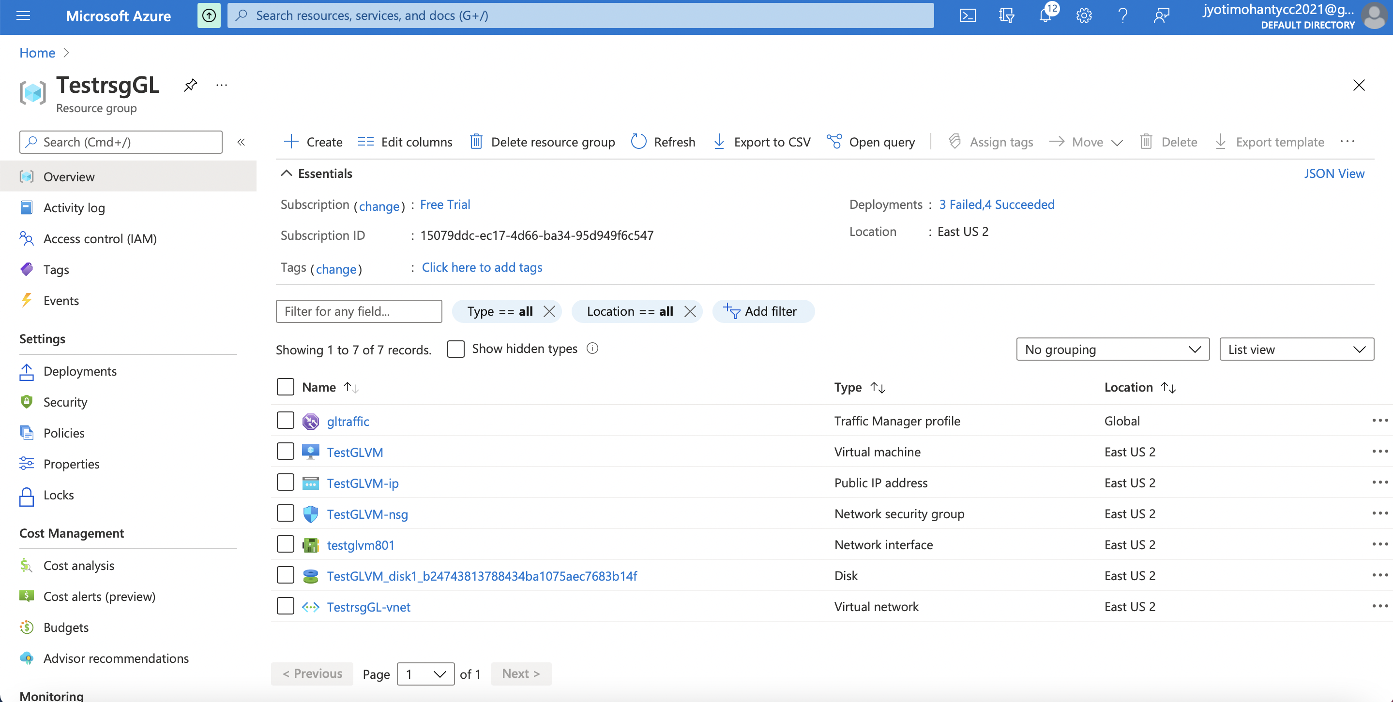

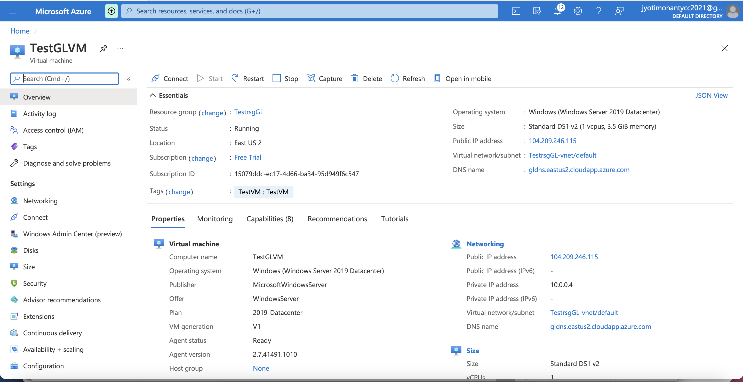

**Step 2: Installation of IIS**

|  |  |  |
| --- | --- | --- |
| Step number | A |  |
| Step name | Installation of IIS server |  |
| Instructions | 1) Navigate to the VM created in the previous step.  2) Connect to the VM using RDP. You can check the link below to learn how to do so <https://docs.microsoft.com/en-us/azure/virtual-machines/windows/connect-logon> Note that Windows users will already have an RDP client installed, while Linux and macOS users will need to install a client such as Remmina or Microsoft Remote Desktop  3) Once the RDP connection has been made, open the PowerShell application in the VM.  4) Install IIS in the VM by entering the below command in the PowerShell *Install-WindowsFeature -name Web-Server -IncludeManagementTools*  5) Ensure IIS is working correctly by access the public IP address of the VM in a web browser |  |
| Expected screenshots | 1) RDP into the instance 2) Installation of IIS using the command  3) Verification of IIS installation |  |

**<Insert screenshot for a(1) here>**

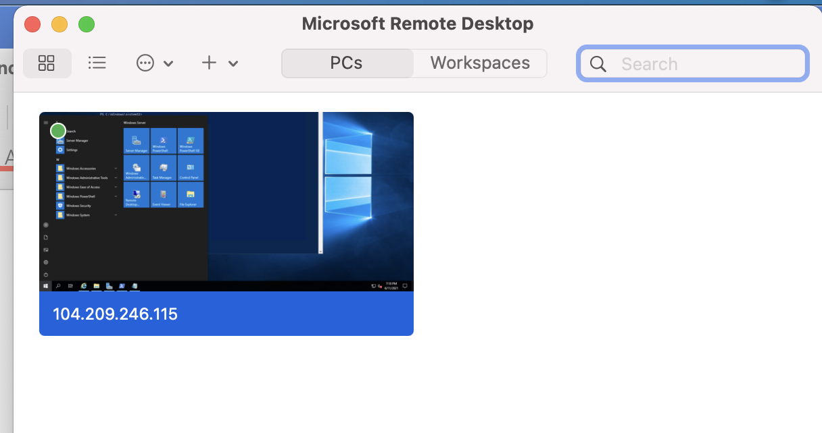

**<Insert screenshot for a(2) here>**

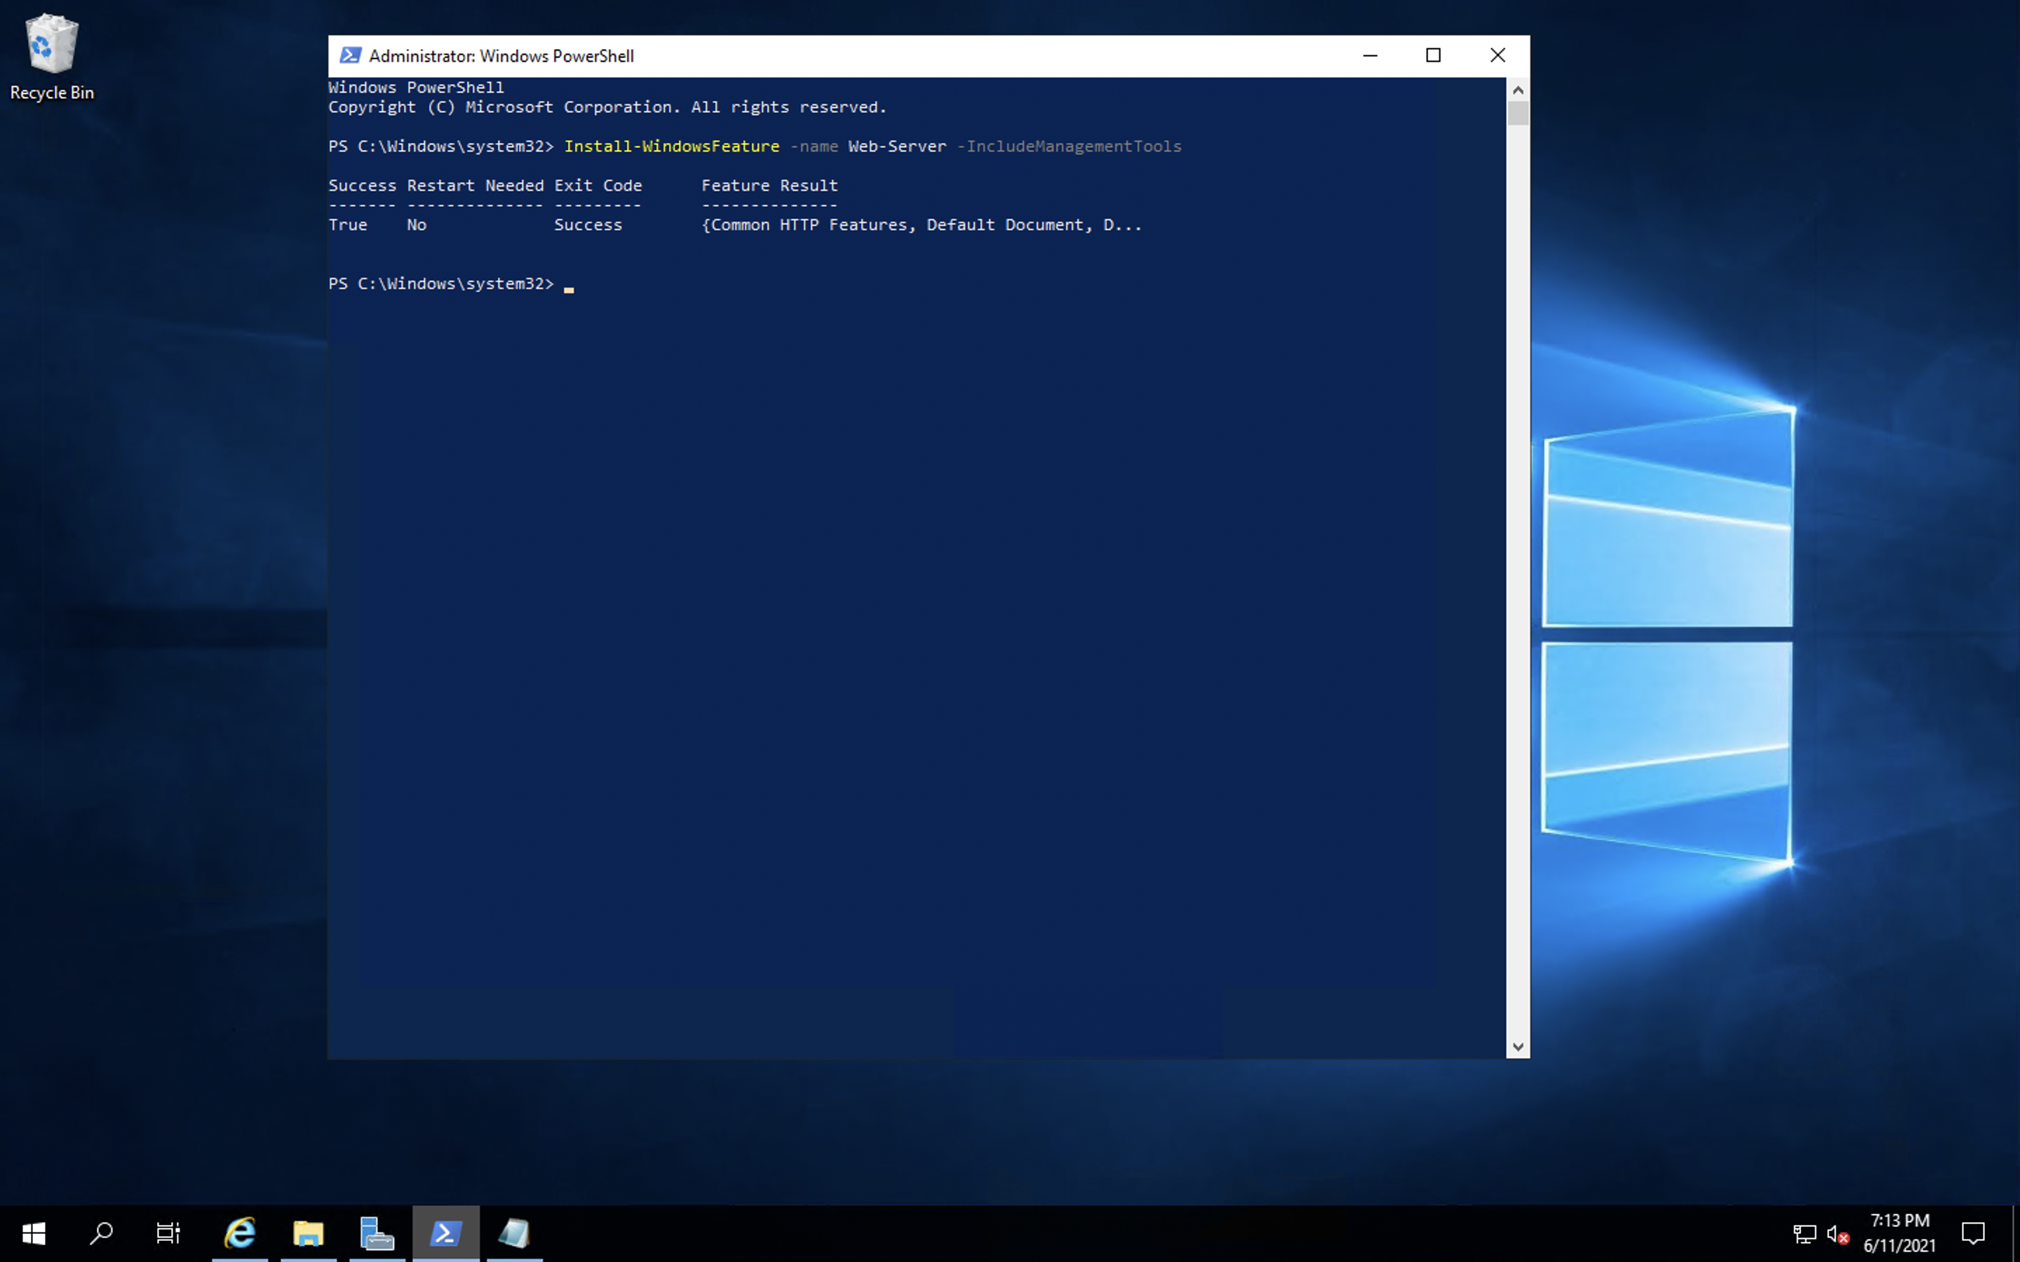

**<Insert screenshot for a(3) here>**

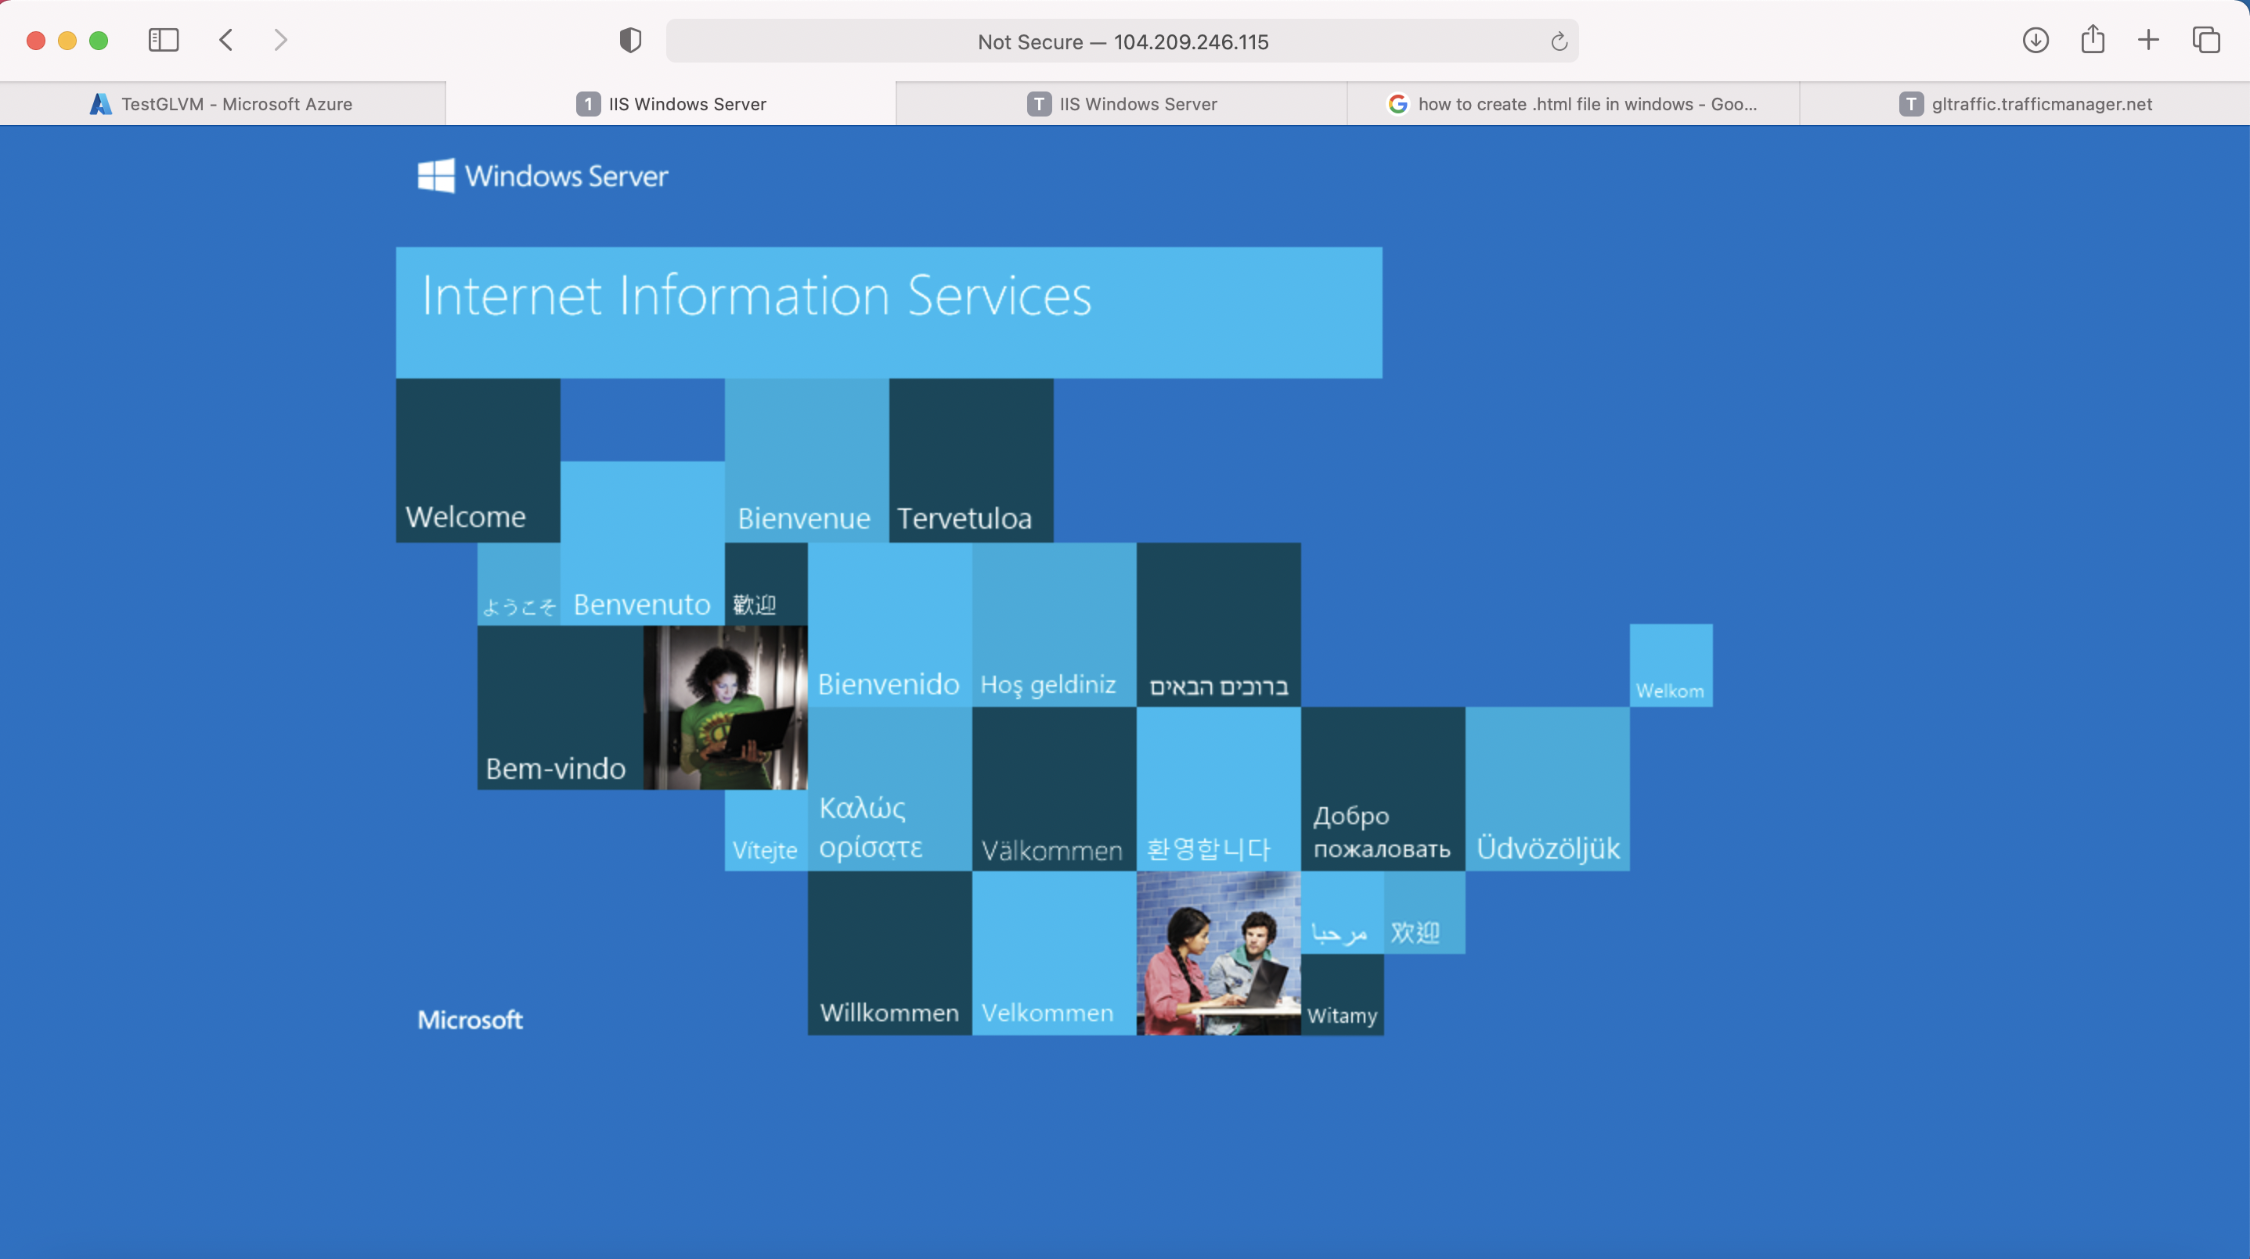

**Step 3: Use Traffic Manager**

|  |  |  |  |  |
| --- | --- | --- | --- | --- |
| Step number | A |  |  |  |
| Step name | Installation and Configuration of Traffic Manager |  |  |  |
| Instructions | 1) In the Azure portal, navigate to the Virtual Machine created previously and go to the Overview page.  2) Under DNS name, click on Configure  3) Enter a DNS name label and click on Save.  4) Navigate to Traffic Manager profiles using the search bar.  5) Create the profile in the same Resource group as created previously. The routing method has to be set to **Performance**  6) Navigate to the created Traffic Manager profile and go to the Endpoints page.  7) Click on **Add** and add the endpoint with the following details  Type : Azure Endpoint  Target Resource Type : Public IP address  Public IP address : Select the IP address of the VM from the drop-down list.  Rest of the fields can be left to the default values.  8) Navigate back to the Overview Page  9) Access the Traffic Manager’s DNS name from a web browser to verify that the web server is being accessed | | | |
| Expected screenshots | 1) Configuration of DNS Name for VM 2) Creation of Traffic Manager Profile 3) Adding of endpoint to the Traffic Manager profile 4) Accessing the webserver via the Traffic Manager | | | |

**<Insert screenshot for a(1) here>**

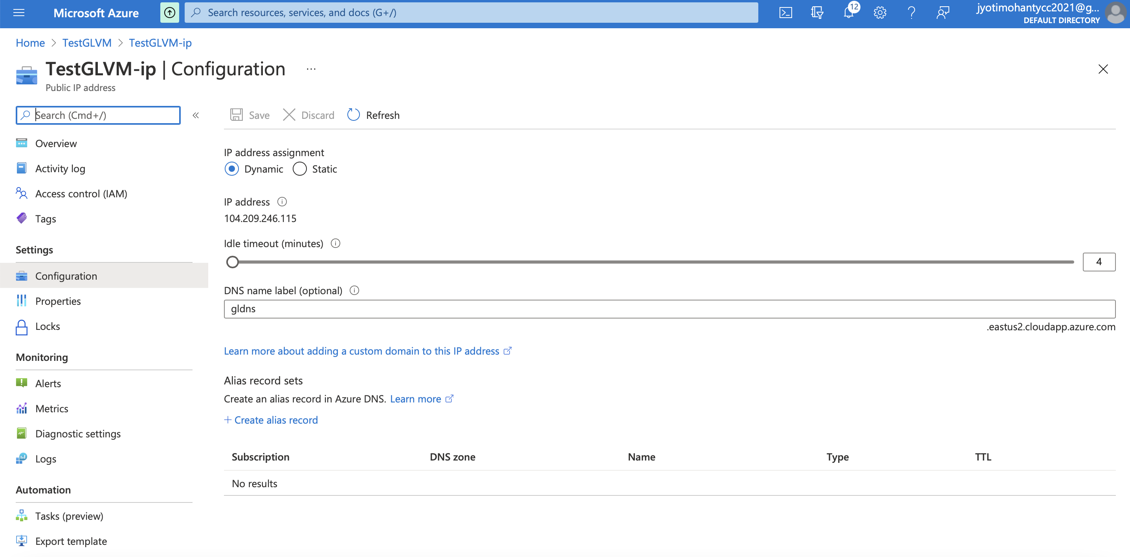

**<Insert screenshot for a(2) here>**

**<Insert screenshot for a(3) here>**

**<Insert screenshot for a(4) here>**

**Step 4 : Modification of IIS home page.**

|  |  |  |  |  |
| --- | --- | --- | --- | --- |
| Step number | a |  |  |  |
| Step name | Modification of IIS home page |  |  |  |
| Instructions | 1) Login into the created VM using RDP  2) Using the file explorer in the VM , navigate to C:\inetpub\wwwroot  3) Create a file called index.html  4) Insert the following text in the index.html file  <html>  <body>  Welcome to Great Learning YourNameHere. This is your Web server.  </body>  </html>  5) Save the file and access the web server again via the Traffic Manager to verify that the modified home page is being displayed. | | | |
| Expected screenshots | 1) Contents of Index.html 2) Modified home page | |  |  |

**<Insert screenshot for a(1) here>**

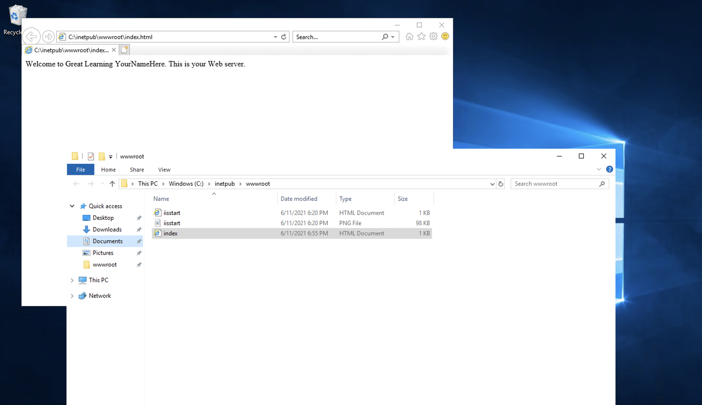

**<Insert screenshot for a(2) here>**

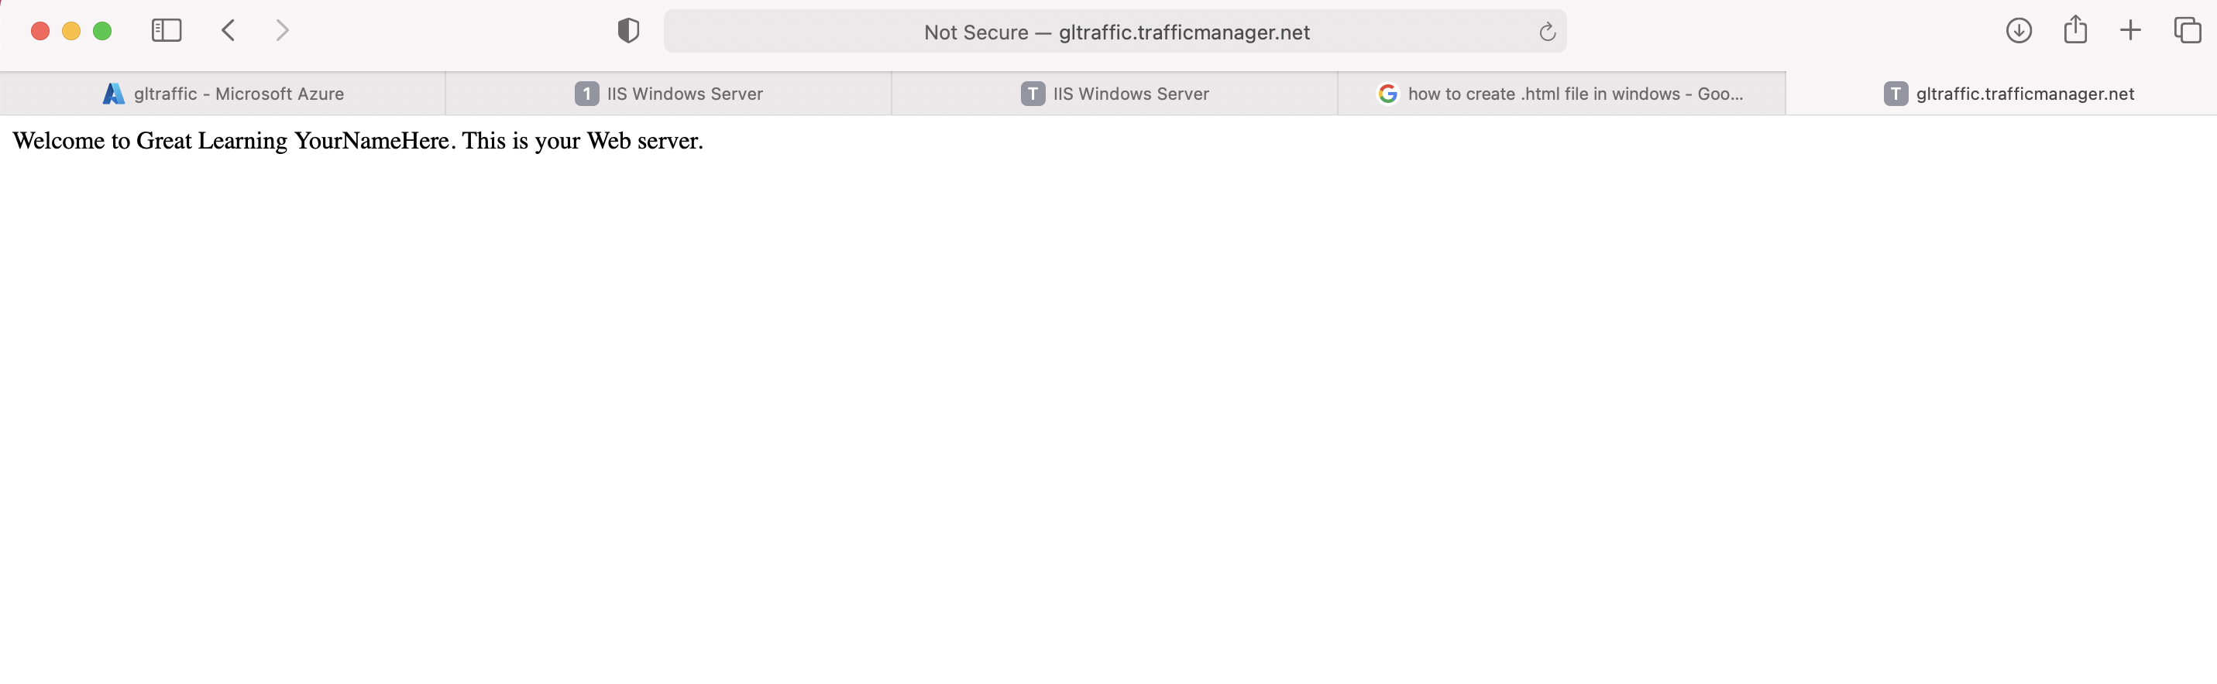

|  |  |  |  |  |
| --- | --- | --- | --- | --- |
| **Answer the following questions** | | | | **Marks** |
| Q1 | Which of the following is the AWS equivalent of the Traffic Manager in Azure? | | | 1 |
|  | a) Application Load Balancer |  |  |  |
|  | b) Route 53 |  |  |  |
|  | c) VPC |  |  |  |
|  | d) Network Load Balancer |  |  |  |
|  | Enter your answer here | b |  |  |
|  |  |  |  |  |
| Q2 | Which port is being used by IIS to display the homepage in this exercise | | | 1 |
|  | a) 80 |  |  |  |
|  | b) 443 |  |  |  |
|  | c) 3306 |  |  |  |
|  | d) 3389 |  |  |  |
|  | Enter your answer here | a |  |  |
|  |  |  |  |  |
| Q3 | Which of the following must be created first before deploying a resource in Azure? | | | 1 |
|  | a) Storage account |  |  |  |
|  | b) Virtual Network |  |  |  |
|  | c) Resource Group |  |  |  |
|  | d) Network Interface |  |  |  |
|  | Enter your answer here | c |  |  |
|  |  |  |  |  |
| Q4 | What is the default number of update domains for an availability set? | | | 1 |
|  | a) 5 |  |  |  |
|  | b) 7 |  |  |  |
|  | c) 3 |  |  |  |
|  | d) 1 |  |  |  |
|  | Enter your answer here | 5 |  |  |
|  |  |  |  |  |
| Q5 | How does the Performance routing method in Traffic Manager prioritize endpoints? | | | 1 |
|  | a) Latency |  |  |  |
|  | b) Geographical location |  |  |  |
|  | c) Weightage |  |  |  |
|  | d) Number of backups |  |  |  |
|  | Enter your answer here | a |  |  |
|  |  |  |  |  |
|  |  |  |  |  |
|  |  |  |  |  |
|  |  |  |  |  |
|  |  |  |  |  |
|  |  |  |  |  |
|  |  |  | **Max marks** | **12** |

|  |  |
| --- | --- |
| **Grades distribution** |  |
| MCQs | 5 marks |
| Implementation screenshots | 15 marks (1.5 marks each) |
| Total | 20marks |